**A.I TDD**

1. **Description [12.5%]:**

The Artificial Intelligence will be used to move an object from location to location on a map. It will be used on the map in the main scene, where there will be location on the map you can click, the object will follow the waypoint system that will be set up to determine how to move from location to location.

1. **Asset Requirements [12.5%]:**

Written list of assets that will be required to complete the tasks.

* MapBox API
* Prefab of Truck Object
* Prefab of Waypoint Manager
* Movement Script
* Waypoint Script
* Load script

1. **FlowChart [25%]:**

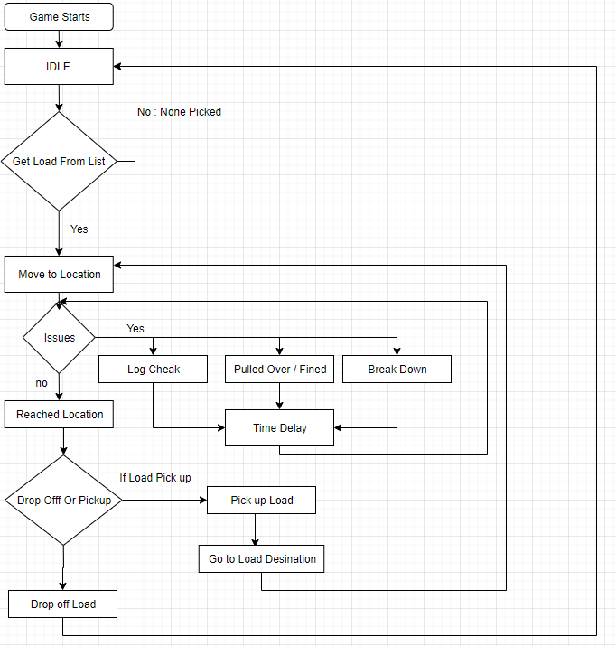

1. **UML Diagrams [25%]:**

UML diagrams break down the classes required for the feature being implemented. Arrows indicate connections via either inheritance or nested objects.

Properties/ attributes should be in the first segment and functionality / operations in the second segment under the class name.

For more depth, use + or – before each of the above to indicate public(+) vs private(-)

You can use <https://www.draw.io/> for free to help create these, or a whiteboard capture.

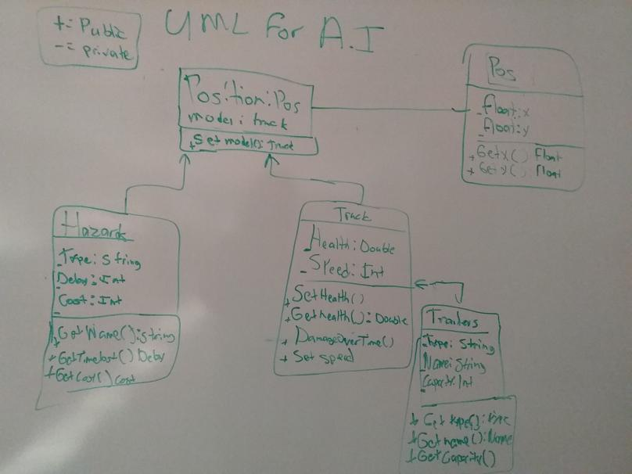

1. **Task List [25%]:**

This is a set of tasks required to complete all of the above.

These should be broken down into segments that could be completed within a 4-8 window of work. Ideally include an estimate on the time required if possible. This should not have names of members of the team associated with the tasks.

* Create Base Classes for AI Script [4 hours]
  + Create AI code [2 hours]
* Add To Mapbox